# Part 1

Could not get the Maven project to work, said I was missing “JAVA-HOME”. Below is a screenshot of the error. BUT, I did code everything out and those files are included.

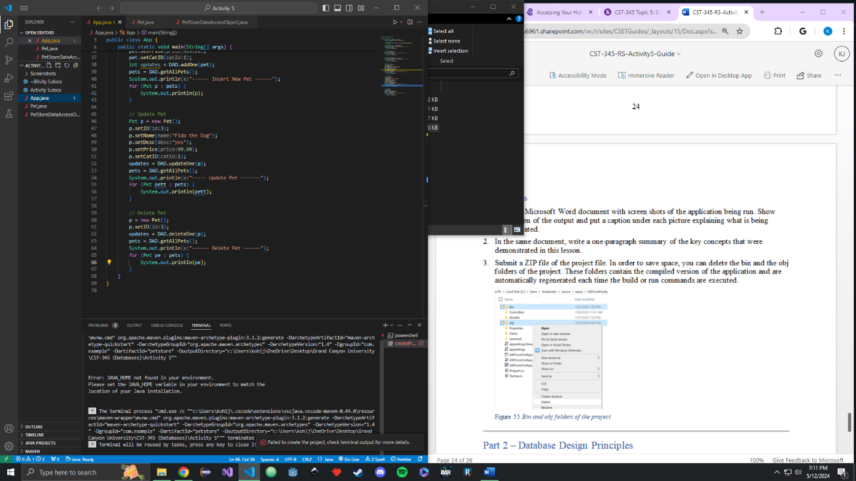

# Part 2

**New Customer**

**New Sales**

**New Author**

**New Work**

**New Book**

